Assignment 4

**Submitted by,**

TeamID:PNT2022TMID34537

1. N. Selva Nancy
2. M. Shiny
3. R. Lenitha
4. P. Mahalakshmi

1.Pull an Image from docker hub and run it in docker playground:

Pulled sandeepdoodigani/plasmaapplication and running in docker:

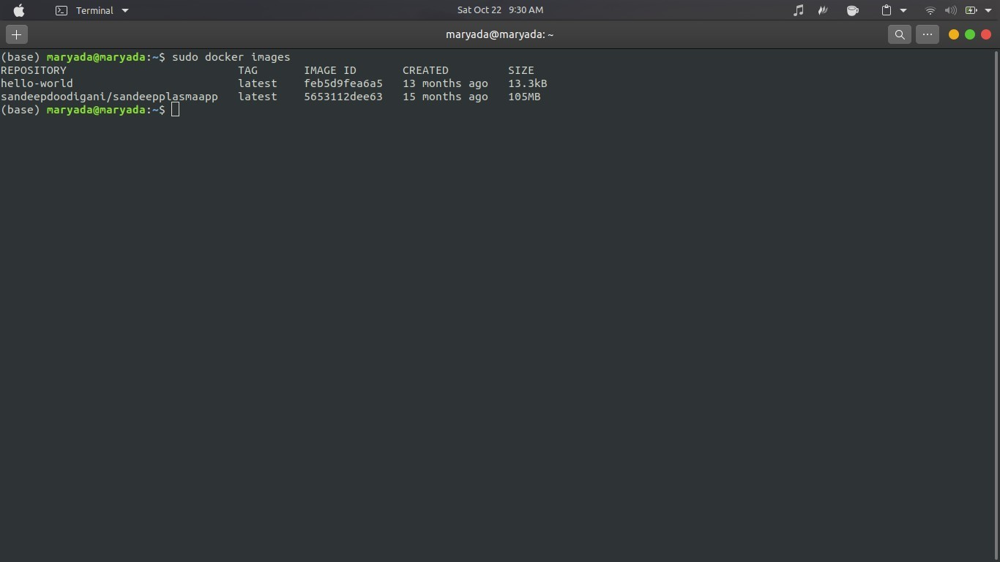

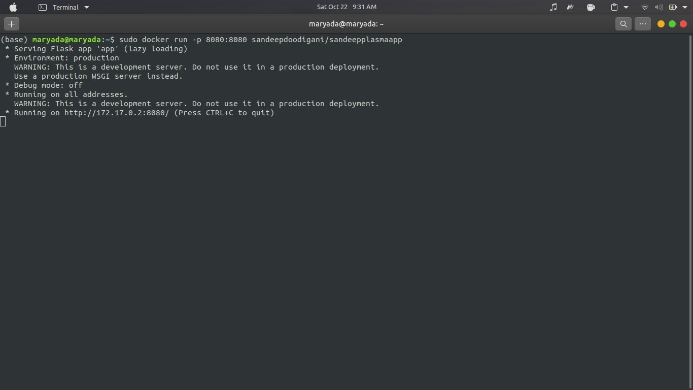

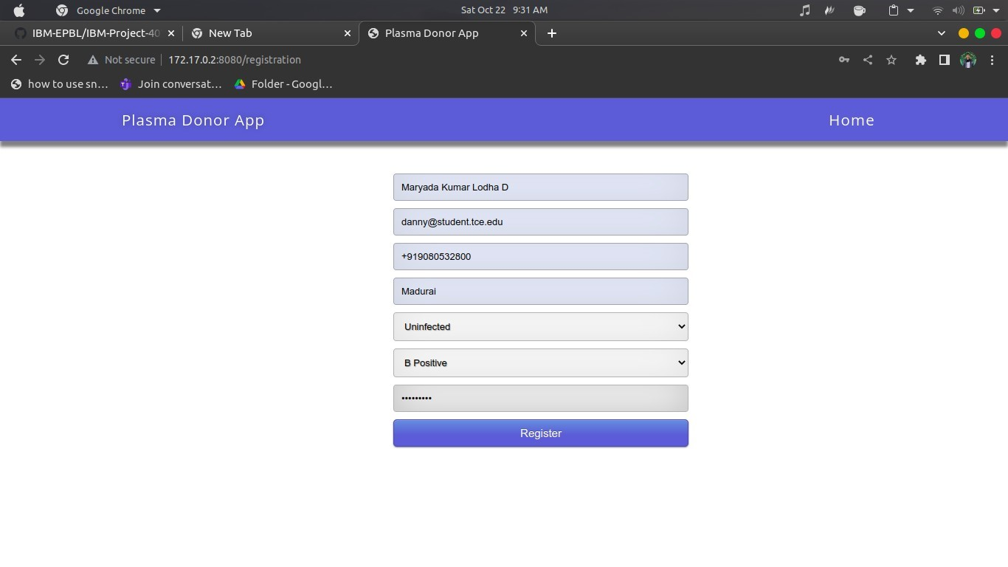

2.Create a docker file for the Job portal application and deploy it in Docker desktop application.

Dockerfile:

FROM python:3.6

WORKDIR/app

ADD./app

COPY requirements.txt /app

RUN python3 -m pip install -r requirements.txt

RUN python3 -m pip install ibm_db

EXPOSE 5000

CMD ["python","app.py"]

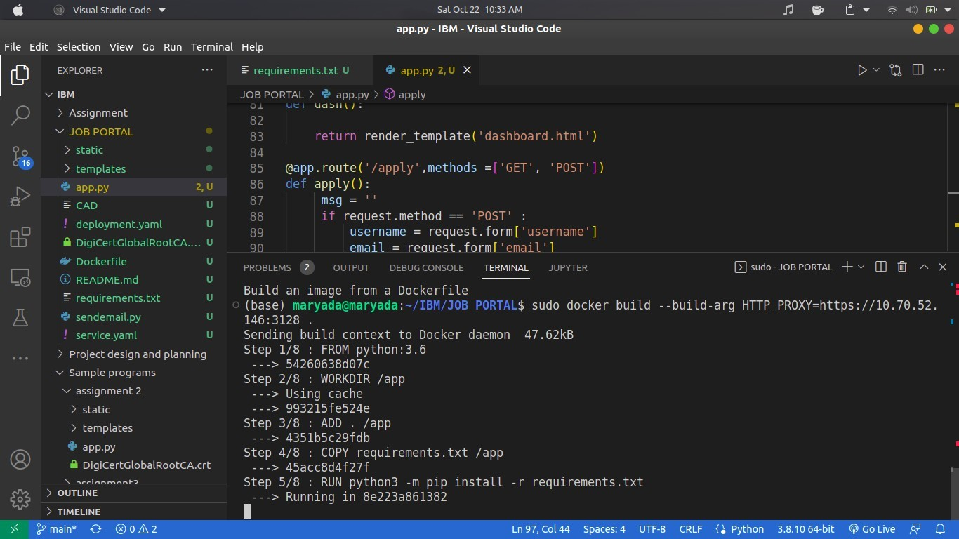

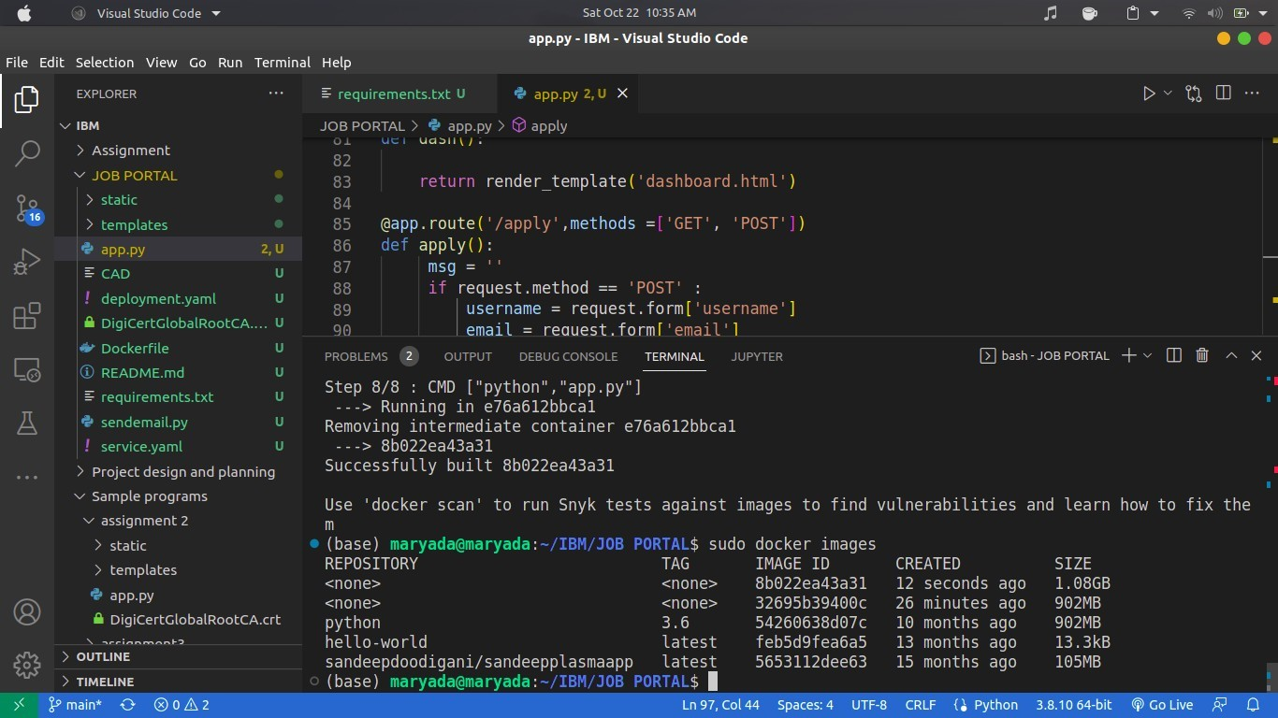

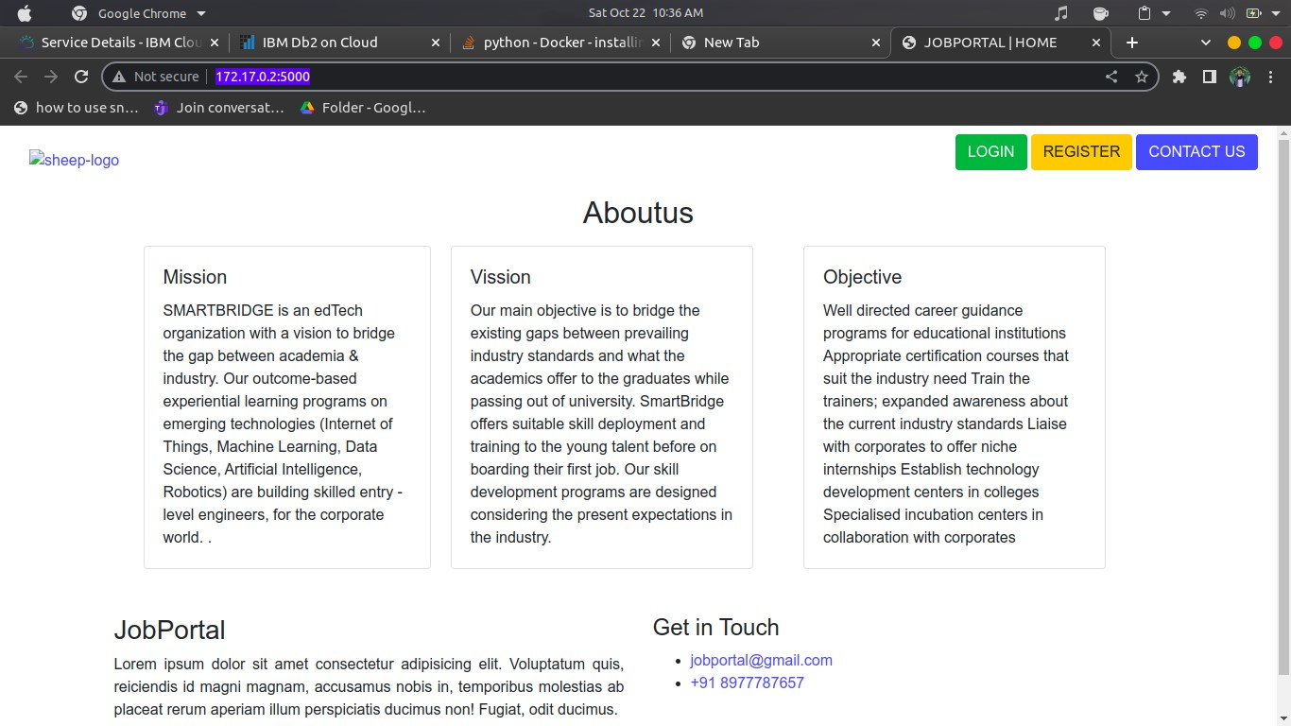

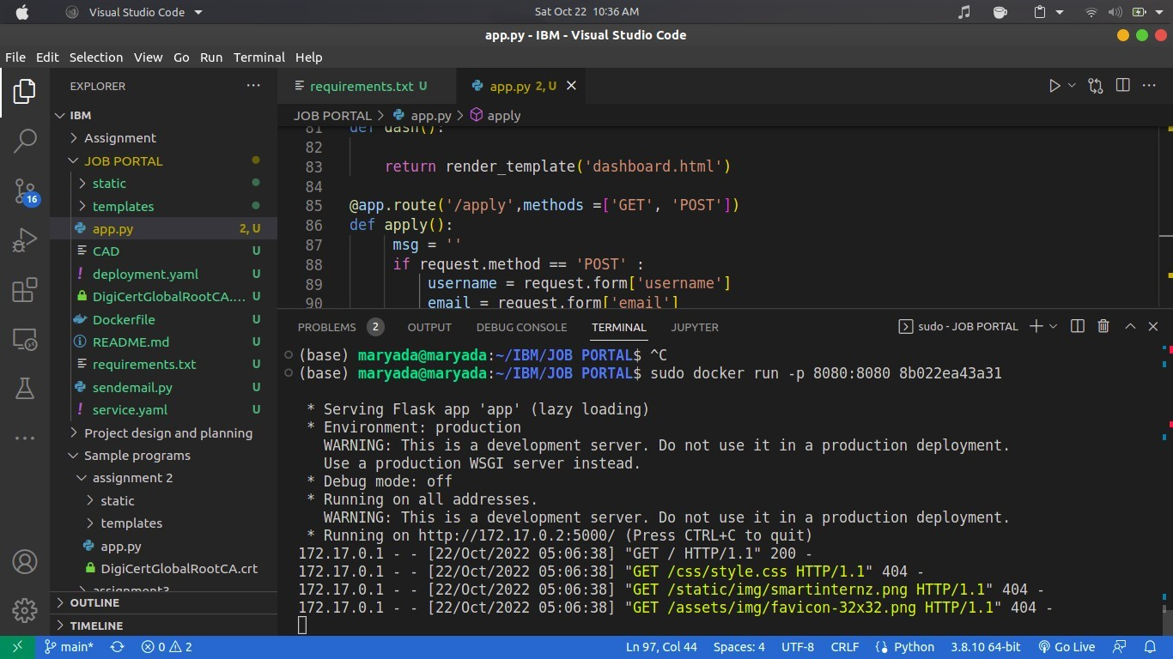

3.Create an IBM container registry and deploy helloworld app or Job portal app.

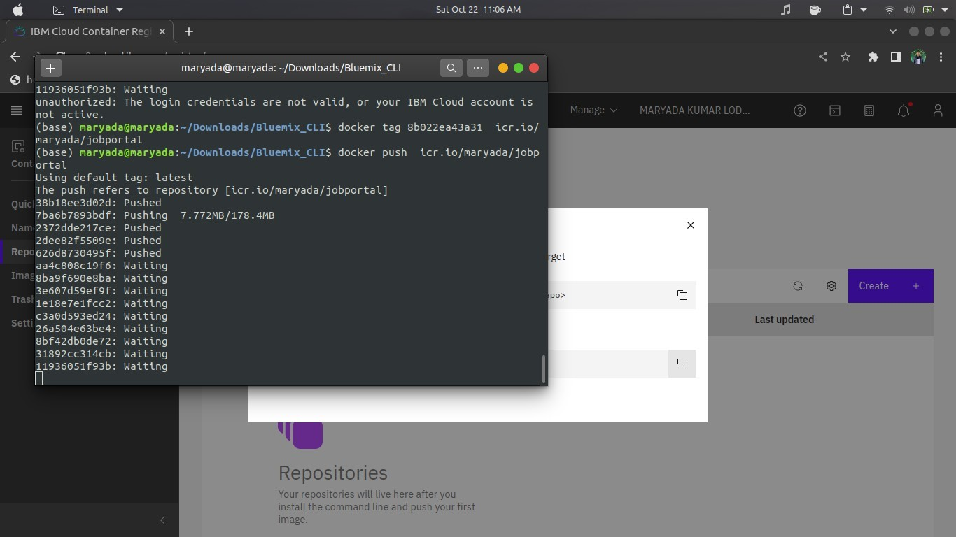

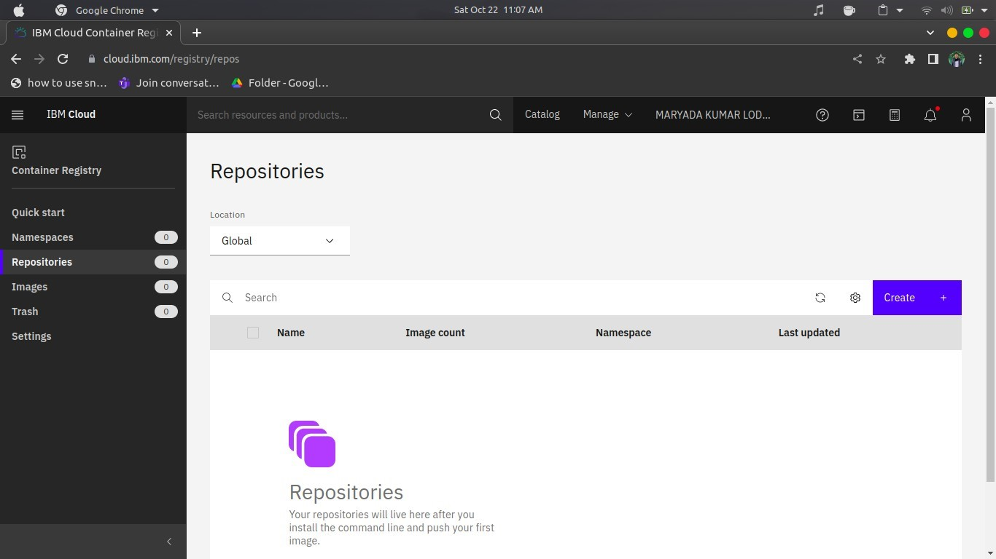

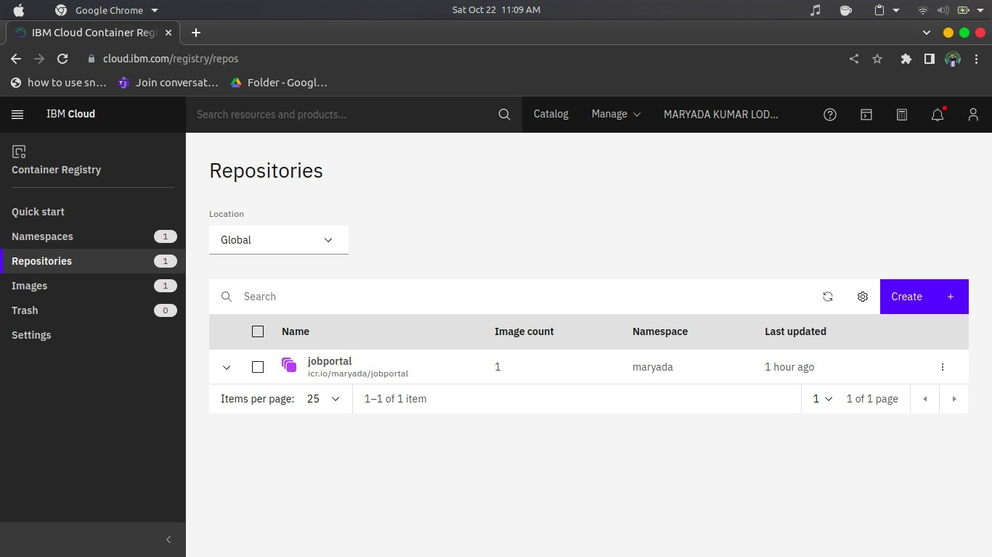

4.Create a Kubernetes cluster in IBM cloud and deploy helloworld image or Job portal image and also expose the same app to run in node port.

